Camden Council Library Service
Book Club Kits
Book Plot Summaries

Australian Fiction
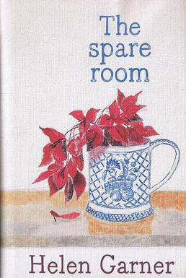 | “The Spare Room” by Helen Garner | Helen lovingly prepares her spare room for her friend Nicola. She is coming to visit for three weeks, to receive treatment she believes will cure her cancer. From the moment Nicola staggers off the plane, gaunt and hoarse but still somehow grand, Helen becomes her nurse, her guardian angel and her stony judge. ‘The Spare Room’ tells a story of compassion, humour and rage. The two women—one sceptical, one stubbornly serene—negotiate an unmapped path through Nicola’s bizarre therapy, stumbling towards the novel’s terrible and transcendent finale.
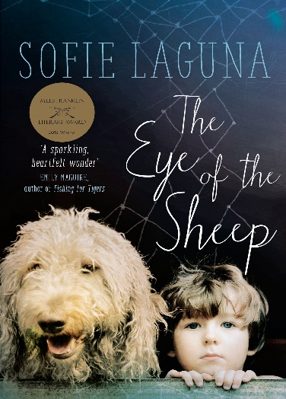 | “The Eye of the Sheep” by Sofie Laguna | Winner of the Miles Franklin Award 2015. Meet Jimmy Flick. He's not like other kids—the's both too fast and too slow. He sees too much, and too little. Jimmy's mother Paula is the only one who can manage him. She teaches him how to count sheep so that he can fall asleep. She holds him tight enough to stop his cells spinning. It is only Paula who can keep Jimmy out of his father's way. But when Jimmy's world falls apart, he has to navigate the unfathomable world on his own and make things right. Sofie Laguna's first novel One Foot Wrong received rave reviews, sold all over the world and was longlisted for the Miles Franklin Literary Award and shortlisted for the Prime Minister's Literary Award. In The Eye of the Sheep, her great originality and talent will again amaze and move readers. In the tradition of Room and The Lovely Bones, here is a surprising and brilliant novel from one of our finest writers.
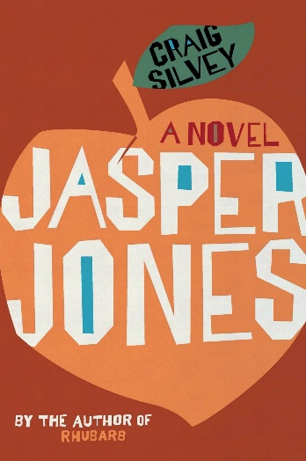 | “Jasper Jones” BY Craig Silvery | Late on a hot summer night in 1965, Charlie Bucktin, a bookish boy of thirteen, is startled by an urgent knock on the window of his sleep-out. His visitor is Jasper Jones, an outcast in the regional mining town of Corrigan. When Jasper begs for his help, Charlie eagerly steals into the night by his side, terribly afraid but desperate to impress. Jasper takes him to his secret glade in the bush, and it's here that Charlie bears witness to Jasper's horrible discovery.
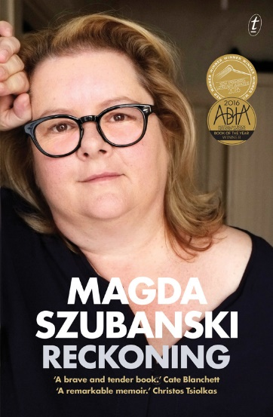 | “Reckoning: A Memoir” by Magda Szubanski | heartbreaking, joyous, traumatic, intimate and revelatory, ‘Reckoning’ is the book where Magda Szubanski, one of Australia’s most beloved performers, tells her story. In this extraordinary memoir, Magda describes her journey of self-discovery from a suburban childhood, haunted by the demons of her father’s espionage activities in wartime Poland and by her secret awareness of her sexuality, to the complex dramas of adulthood and her need to find out the truth about herself and her family. With courage and compassion, she addresses her own frailties and fears, and asks the big questions about life, about the shadows we inherit and the gifts we pass on. Honest, poignant, utterly captivating, Reckoning announces the arrival of a fearless writer and natural storyteller. It will touch the lives of its readers
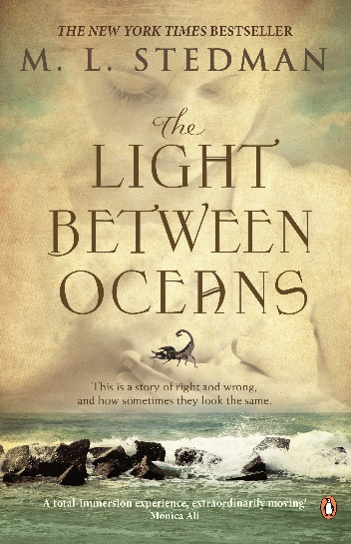 | “The Light Between Oceans” by M.L. Stedman | they break the rules and follow their hearts. What happens next will break yours. 1926. Tom Sherbourne is a young lighthouse keeper on a remote island off Western Australia. The only inhabitants of Janus Rock, he and his wife Isabel live a quiet life, cocooned from the rest of the world. Then one April morning a boat washes ashore carrying a dead man and a crying infant - and the path of the couple's lives hits an unthinkable crossroads. Only years later do they discover the devastating consequences of the decision they made that day - as the baby's real story unfolds. Historical Novel of the Year 2012 by Goodreads' reading community.
 | “The Slap” by Christos Tsiolkas | to smack or not to smack is the question that reverberates through the interconnected lives dissected in Christos Tsiolkas' 2009 Commonwealth Writers' Prize winning novel. At a suburban barbecue, a man slaps a child who is not his own. It is a single act, but the slap reverberates through the lives of everyone who witnesses it. Told through the eyes of eight of those present at the barbecue, this acclaimed bestseller is an unflinching interrogation of the life of the modern family. Poignant and provocative, ‘The Slap’ makes us question the nature of commitment and happiness, compromise and truth. Whose side are you on?
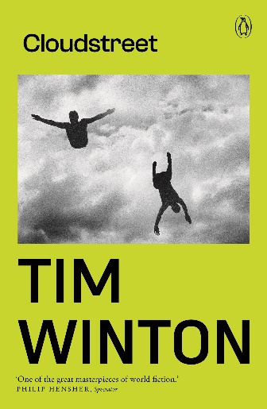 | “Cloudstreet” by Tim Winton | Winner of the Miles Franklin in 1992, ‘Cloudstreet’ chronicles the lives of two families who flee their rural livings to share a house in the Perth suburb of West Leederville. Though initially resistant to each other, their search and journey for meaning in life brings the families closer together
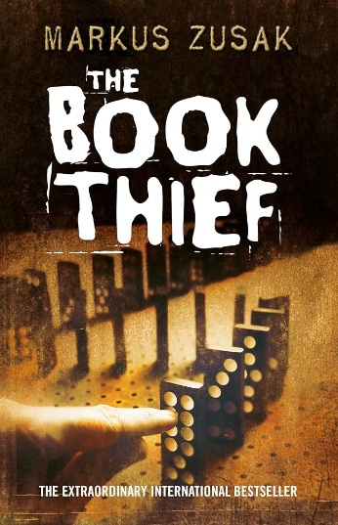 | “the Book Thief” by Markus Zusak | It is 1939, Nazi Germany. Liesel Meminger scratches out a meagre existence by stealing books wherever there are books to be found. When Leisel’s foster family hides a Jewish fist-fighter in their basement, Leisel’s world is both opened, and closed down.

Fiction
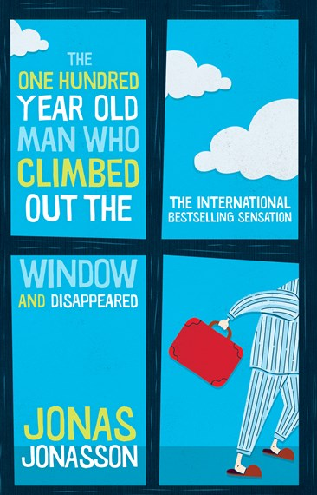 | “The One-Hundred-Year-Old Man Who Climbed Out The Window And Disappeared” by Jonas Jonasson | Sitting quietly in his room in an old people's home, Allan Karlsson is waiting for a party he doesn't want to begin. His one-hundredth birthday party to be precise. The Mayor will be there. The press will be there. But, as it turns out, Allan will not . . . Escaping (in his slippers) through his bedroom window, into the flowerbed, Allan makes his getaway. And so begins his picaresque and unlikely journey involving a suitcase full of cash, a few thugs, a very friendly hot-dog stand operator, a few deaths, an elephant and incompetent police. As his escapades unfold, Allan's earlier life is revealed. A life in which - remarkably - he played a key role behind the scenes in some of the momentous events of the twentieth century. The One Hundred-Year-Old Man Who Climbed Out the Window and Disappeared is a charming, warm and funny novel, beautifully woven with history and politics
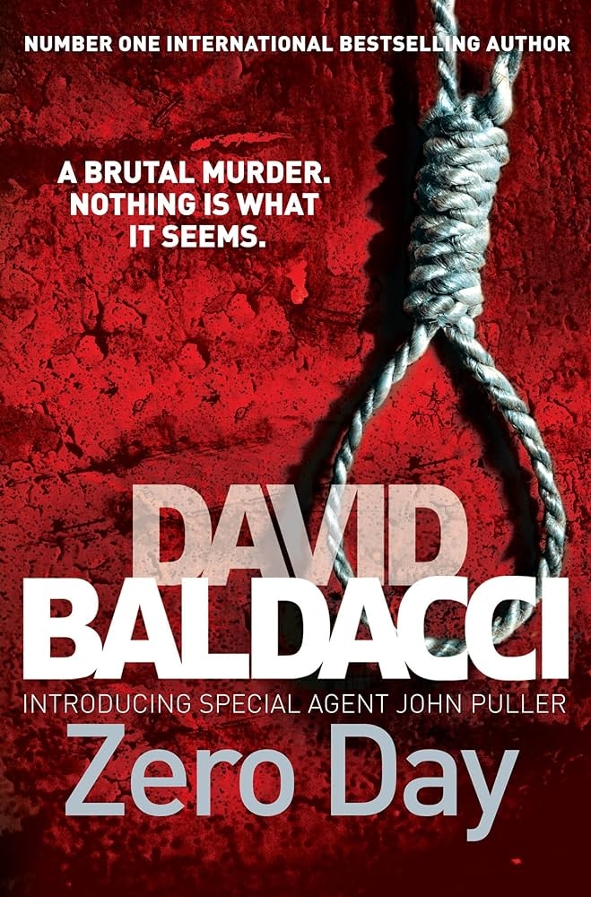 | “Zero Day” by David Baldacci | When a family with military connections is brutally murdered in a remote area of West Virginia, war hero and CID investigator John Puller is called in, teaming up with local homicide detective Samantha Cole. As the body count rises, it quickly becomes apparent that there’s much more to this case than they had first thought.
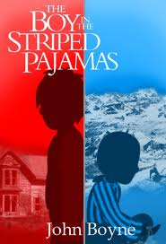 | “The Boy in the Striped Pyjamas” by John Boyne | Nine-year-old Bruno has a lot of things on his mind. Who is the 'Fury'? Why did he make them leave their nice home in Berlin to go to 'Out-With'? And who are all the sad people in striped pyjamas on the other side of the fence? The grown-ups won't explain so Bruno decides there is only one thing for it—he will have to explore this place alone. What he discovers is a boy in striped pyjamas. But why can't they ever play together?
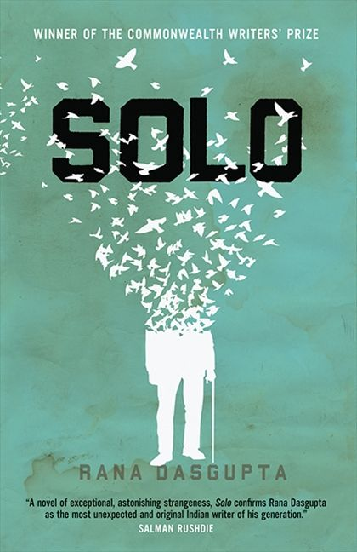 | “Solo” by Rana Dasgupta | Ulrich, the son of a railroad engineer, has two great passions—the violin and chemistry. Denied the first by his father, he leaves for the Berlin of Einstein and Fritz Haber to study the latter. His studies are cut short when his father's fortune evaporates, and he must return to Sofia. He never leaves Bulgaria again—except in his daydreams. This novel won the Commonwealth Writers’ Prize in 2010.
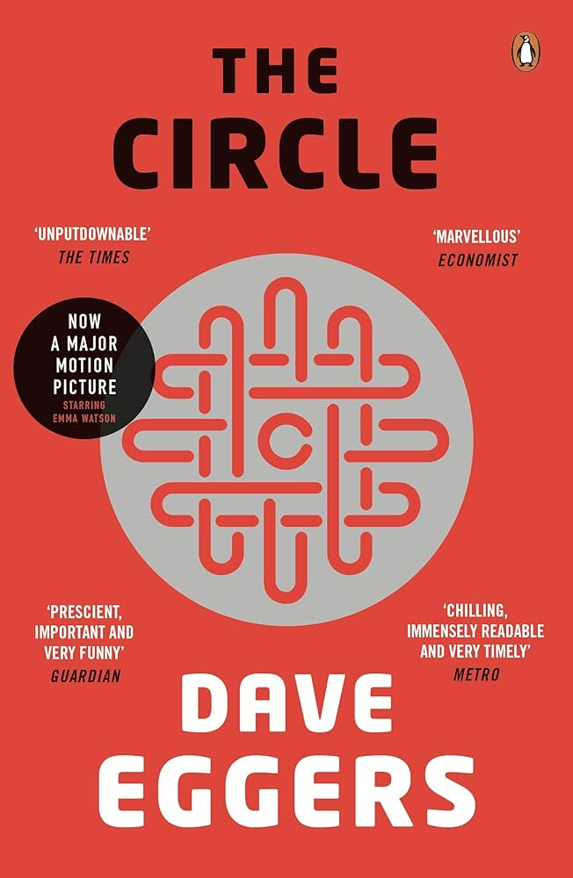 | “The Circle” by Dave Eggers | When Mae Holland is hired to work for the Circle, the world's most powerful internet company, she feels she's been given the opportunity of a lifetime. The Circle, run out of a sprawling California campus, links users' personal emails, social media, banking, and purchasing with their universal operating system, resulting in one online identity and a new age of civility and transparency. As Mae tours the open-plan office spaces, the towering glass dining facilities, the cozy dorms for those who spend nights at work, she is thrilled with the company's modernity and activity. There are parties that last through the night, there are famous musicians playing on the lawn, there are athletic activities and clubs and brunches, and even an aquarium of rare fish retrieved from the Marianas Trench by the CEO. Mae can't believe her luck, her great fortune to work for the most influential company 10 in the world-even as life beyond the campus grows distant, even as a strange encounter with a colleague leaves her shaken, even as her role at the Circle becomes increasingly public. What begins as the captivating story of one woman's ambition and idealism soon becomes a heart-racing novel of suspense, raising questions about memory, history, privacy, democracy, and the limits of human knowledge.
 | “Four Novels” by George Elliot | Adam Bede tells a story of seduction, and is also a pioneering record of a long lost rural world. ‘Middlemarch’ is a complex tale of idealism, disillusion, loyalty and frustrated love. ‘The Mill on the Floss’ is a masterpiece of ambiguity in which moral choice is subjected to the hypocrisy of the Victorian age. ‘Silas Marner’ tells the tender and moving story of an unjustly exiled linen weaver in the agricultural heartland of England.
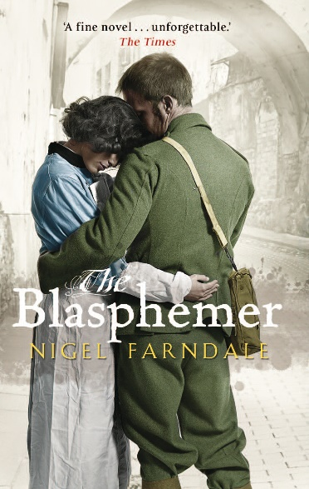 | “The Blasphemer” by Nigel Farndale | A light aircraft ditches into the sea. As the water floods through the cabin, Daniel Kennedy faces an impossible choice—should he save himself, or Nancy, the woman he loves? In a parallel narrative, it is 1917 and Daniel’s great-grandfather Andrew is preparing to go over the top at Passchendaele. He, too, will have his courage tested, and must live with the moral consequences of his actions.
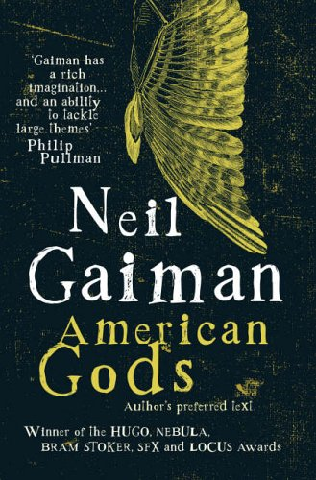 | “American Gods” by Neil Gaiman | Days before his release from prison, Shadow's wife, Laura, dies in a mysterious car crash. On the plane home, he encounters the enigmatic Mr Wednesday, who claims to be a refugee from a distant war, a former god and the king of America. Together they embark on a profoundly strange journey across the heart of the USA, whilst all around them a storm of epic proportions threatens to break.
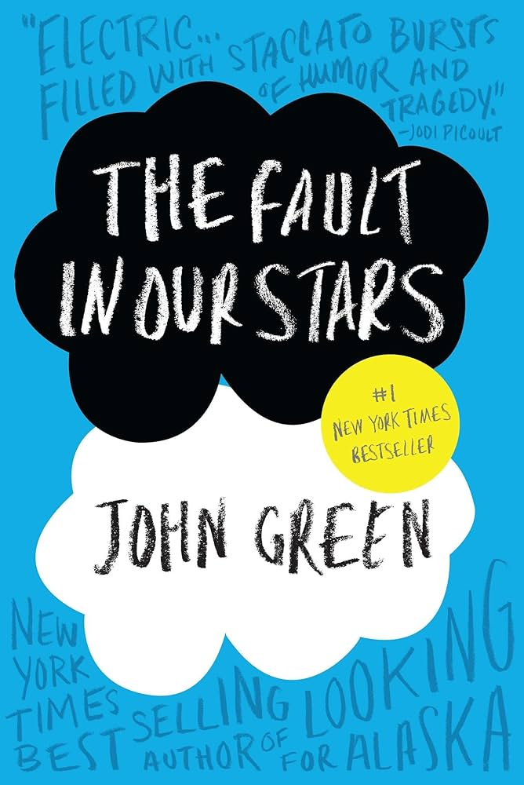 | “The Fault in Our Stars” by John Green | Despite the tumour-shrinking medical miracle that has bought her a few years, Hazel has never been anything but terminal, her final chapter inscribed upon diagnosis. But when a gorgeous plot twist named Augustus Waters suddenly appears at Cancer Kid Support Group, Hazel’s story is about to be completely rewritten.
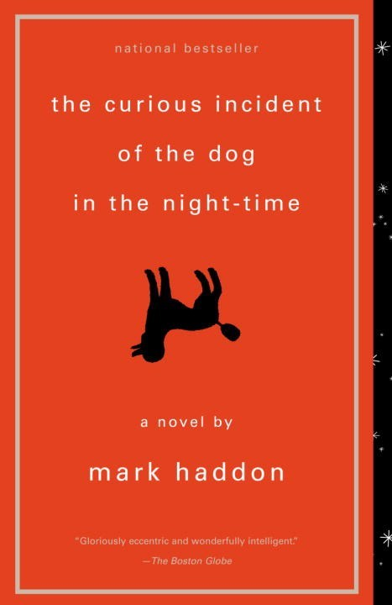 | “The Curious Incident of the Dog in the Night-Time” by Mark Haddon | Christopher knows all the countries of the world and their capitals and every prime number up to 7,057. He relates well to animals but has no understanding of human emotions. Although gifted with a superbly logical brain, Christopher is autistic. Christopher’s carefully constructed world falls apart when he finds his neighbour’s dog, Wellington, impaled on a garden fork, and he is initially blamed for the killing. Christopher decides that he will track down the real killer and turns to his favourite fictional character, Sherlock Holmes, for inspiration.
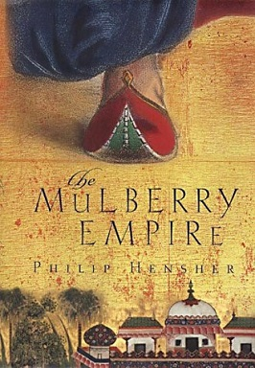 | “The Mulberry Empire” by Phillip Hensher | This epic historical novel relates England’s tragic adventure in Afghanistan, which began with the triumphant arrival of the Army of the Indus in 1839 and ended three years later in rout and massacre. Alexander Burnes, a Scots explorer, travels to the kingdom of Afghanistan and first befriends and then reluctantly betrays its wise and impeccably courteous Amir.
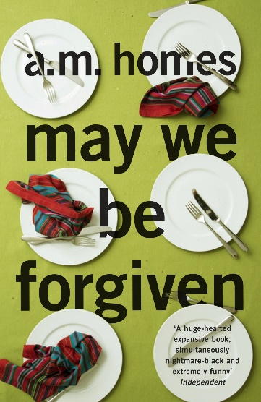 | “May We Be Forgiven” by A.M. Homes | Harold Silver has spent a lifetime watching his younger brother, George, acquire a covetable wife, two kids, and a beautiful home. But when George loses control the result is an act of violence so shocking that both brothers are hurled into entirely new lives. Harry finds himself suddenly playing parent to his brother’s two adolescent children. ‘May We Be Forgiven’ is a tale of how one deeply fractured family might begin to put itself back together.
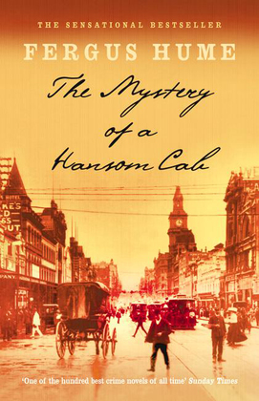 | “The Mystery of a Hansom Cab” by Fergus Hume | First published in 1886 and set in Melbourne, ‘The Mystery of a Hansom Cab’ follows Detective Gorby as he investigates a homicide where the deceased was discovered in the evening inside of a hansom cab, implicating the influential and secretive Frettlby family. Recently made into a TV series for the ABC
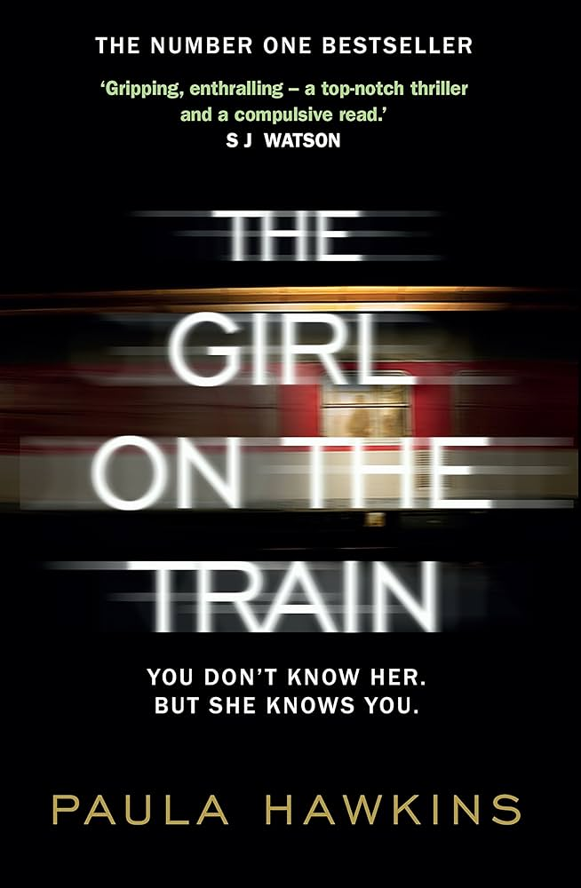 | “The Girl on The Train” by Paula Hawkins | Rachel catches the same commuter train every morning. She knows it will wait at the same signal each time, overlooking a row of back gardens. She's even started to feel like she knows the people who live in one of the houses. ‘Jess and Jason', she calls them. Their life—as she sees it—is perfect. If only Rachel could be that happy. And then she sees something shocking. It's only a minute until the train moves on, but it's enough. Now everything's changed. Now Rachel has a chance to become a part of the lives she's only watched from afar. Now they'll see; she's much more than just the girl on the train…
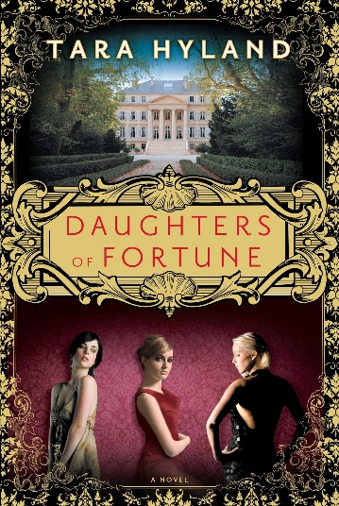 | “Daughters of Fortune” by Tara Hyland | Fifteen year old Caitlin is forced to live with the father she has never met after her mother dies. Her half-sisters react to her with hostility. Unable to fit into this world, Caitlin is sent away to boarding school. It is here that something happens which is so awful it will change Caitlin forever. Over the next fifteen years the sisters' lives will take them in very different directions, their paths will continue to cross in ways that shatter and surprise them.
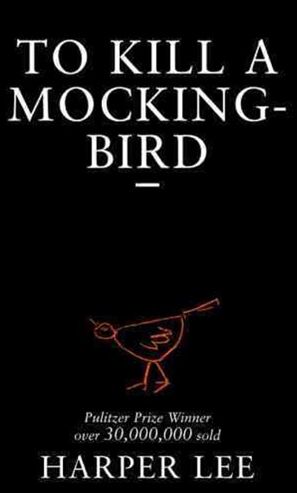 | “To Kill a Mockingbird” by Harper Lee | Scout, her brother Jem, and their lawyer father Atticus are plunged into a conflict that indelibly marks their lives—and gives Scout some basis for thinking she knows just about as much about the world as she needs to.
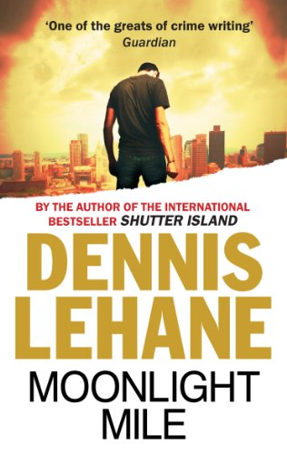 | “MoonLight Mile” by Dennis Lehane | Amanda McCready was four years old when she first vanished from a Boston neighbourhood twelve years ago. Now Amanda is sixteen and gone again. In their desperate fight to confront the past and find Amanda again, investigators Kenzie and Gennaro face an evil that goes beyond broken families.
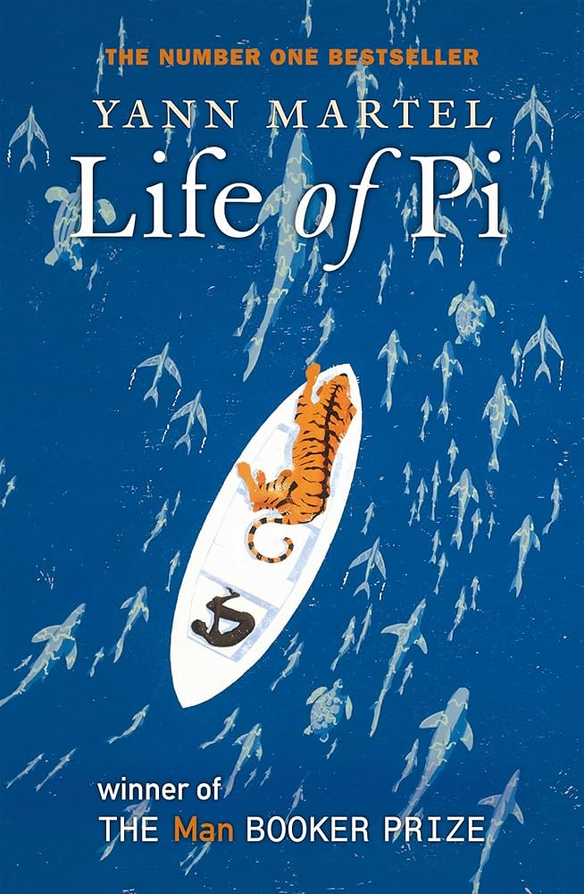 | “Life of Pi” by Yann Martel | This fantasy adventure follows Piscine Molitor "Pi" Patel, a Tamil boy from Pondicherry, who survives 227 days after a shipwreck while stranded on a boat in the Pacific Ocean with a Bengal tiger named Richard Parker. Recently made into a film, this novel was winner of the 2002 Man Booker Prize for Fiction
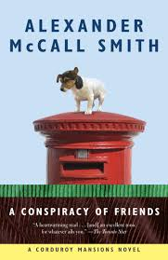 | “A Conspiracy of Friends” by Alexander McCall Smith | The third novel in the ‘Corduroy Mansions’ series features a cast of charming eccentrics, including perhaps the world’s most clever terrier, make their home in a handsome, though slightly dilapidated, apartment block.
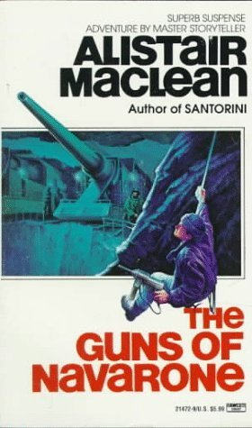 | “The Guns of Navarone” by Alistair Maclean | New Zealand mountaineer-turned-commando Keith Mallory leads an Allied commando team as they seek to destroy a German fortress that threatens Allied naval ships in the Aegean Sea. At risk is the lives of over 2,000 British soldiers. The story is based on the real events surrounding the Battle of Leros in World War II.
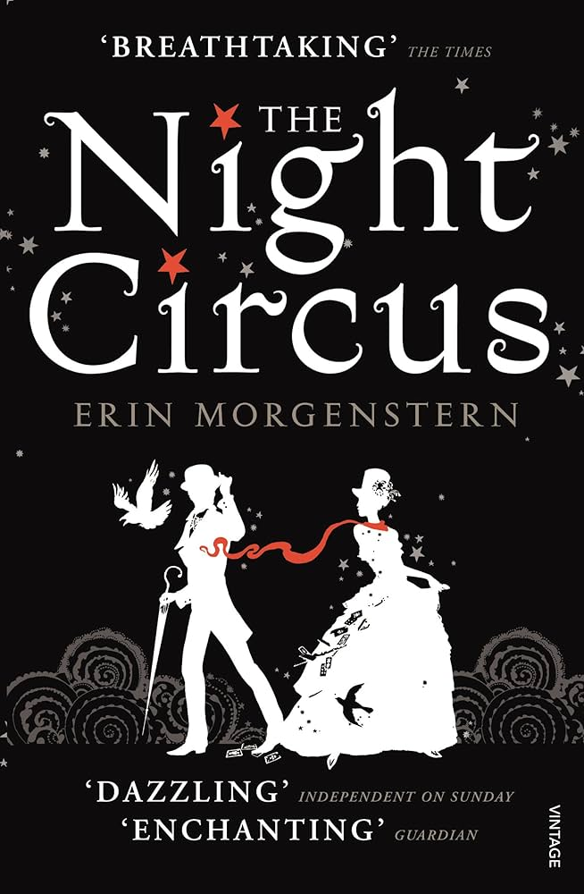 | “Night Circus” by Erin Morganstern | A duel between two young magicians, Celia and Marco, is a game in which only one can be left standing, and the circus is but the stage for a remarkable battle of imagination and will.
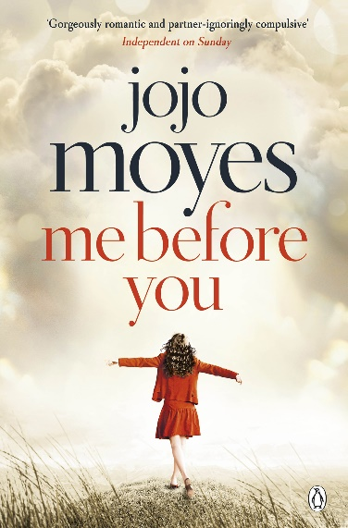 | “Me, Before You” by Jojo Moyes | Lou Clark knows lots of things. She knows how many footsteps there are between the bus stop and home. She knows she likes working in The Buttered Bun tea shop and she knows she might not love her boyfriend Patrick. What Lou doesn't know is she's about to lose her job or that knowing what's coming is what keeps her sane. Will Traynor knows his motorcycle accident took away his desire to live. He knows everything feels very small and rather joyless now and he knows exactly how he's going to put a stop to that.What Will doesn't know is that Lou is about to burst into his world in a riot of colour. And neither of them knows they're going to change the other for all time.
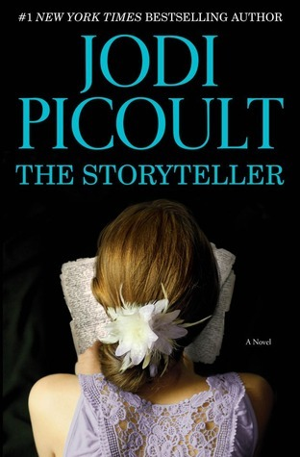 | “the Storyteller” by Jodi Picoult | When Josef Weber, an elderly man in Sage Singer’s grief support group, begins stopping by her bakery, they strike up an unlikely friendship. Everything changes on the day that Josef confesses a long-buried and shameful secret and asks Sage for an extraordinary favour.
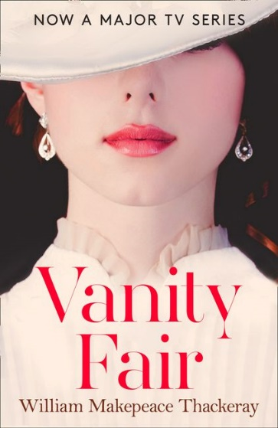 | “Vanity Fair” by William Makepeace- Thackeray | In this epic tale of love and social adventure, no one is better equipped in the struggle for wealth and worldly success than the alluring and ruthless Becky Sharp, who defies her impoverished background to clamber up the social ladder. Her companion Amelia, however, longs for caddish soldier George. As the two heroines make their way through the tawdry glamour of English society in the early 1800s, battles are fought, and fortunes are made and lost.
 | “The Love Hypothesis” by Ali Hazelwood | 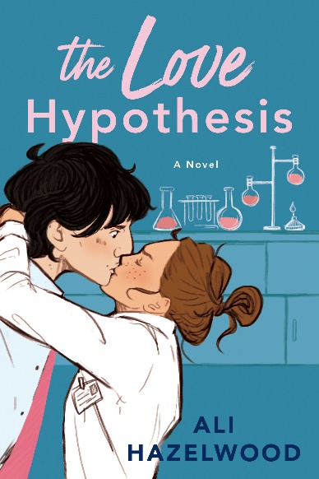  As a third-year Ph.D. candidate, Olive Smith doesn't believe in lasting romantic relationships--but her best friend does, and that's what got her into this situation. Convincing Anh that Olive is dating and well on her way to a happily ever after was always going to take more than hand-wavy Jedi mind tricks: Scientists require proof. So, like any self-respecting biologist, Olive panics and kisses the first man she sees.  That man is none other than Adam Carlsen, a young hotshot professor--and well-known ass. Which is why Olive is positively floored when Stanford's reigning lab tyrant agrees to keep her charade a secret and be her fake boyfriend. But when a big science conference goes haywire, putting Olive's career on the Bunsen burner, Adam surprises her again with his unyielding support and even more unyielding... six-pack abs.  Suddenly their little experiment feels dangerously close to combustion. And Olive discovers that the only thing more complicated than a hypothesis on love is putting her own heart under the microscope.
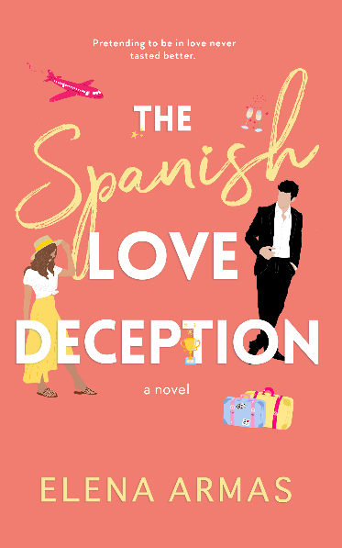 | “The Spanish Love Deception” by Elena Armas | Catalina Martín desperately needs a date to her sister’s wedding. Especially since her little white lie about her American boyfriend has spiralled out of control. Now everyone she knows—including her ex and his fiancée—will be there and eager to meet him.  She only has four weeks to find someone willing to cross the Atlantic and aid in her deception. New York to Spain is no short flight and her raucous family won’t be easy to fool.  Enter Aaron Blackford—her tall, handsome, condescending colleague—who surprisingly offers to step in. She’d rather refuse; never has there been a more aggravating, blood-boiling, and insufferable man.  But Catalina is desperate, and as the wedding draws nearer, Aaron looks like her best option. And she begins to realize he might not be as terrible in the real world as he is at the office.
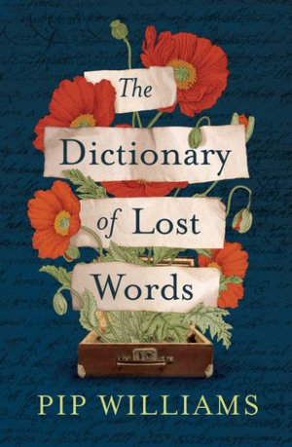 | “The dictionary of Lost Words” by Pip Williams | Set when the women’s suffrage movement was at its height and the Great War loomed, The Dictionary of Lost Words reveals a lost narrative, hidden between the lines of a history written by men. It’s a delightful, lyrical and deeply thought-provoking celebration of words, and the power of language to shape the world and our experience of it.
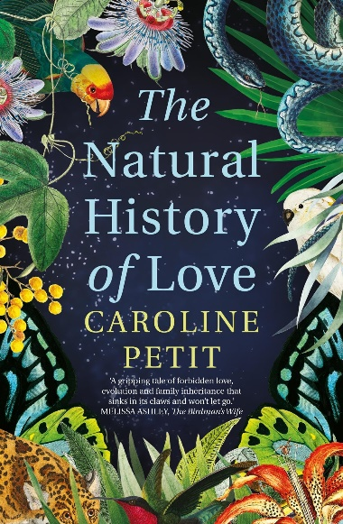 | “The Natural History of Love” by Caroline Petit | When Melbourne lawyer Nathan Smithson takes on the case of mad, wealthy Edward Fonçeca’s inheritance trial against his ruthless brother in 1902, he must unearth long-buried family secrets to have any chance of winning.  Brazil, 1852: François, the Count de Castelnau and French Consul to Bahia falls dangerously ill on a naturalist expedition and is delivered by a rainforest tribesman to the Fonçeca household. Carolina Fonçeca is 16 years old and longing to leave the confines of her family’s remote Brazilian sugar plantation. With a head full of Balzac and dreams of Parisian life, she is instantly beguiled by the middle-aged Frenchman. What Carolina doesn't know is that François has a wife and son back in France. Desperate for a new life, she makes a decision that will haunt her forever.
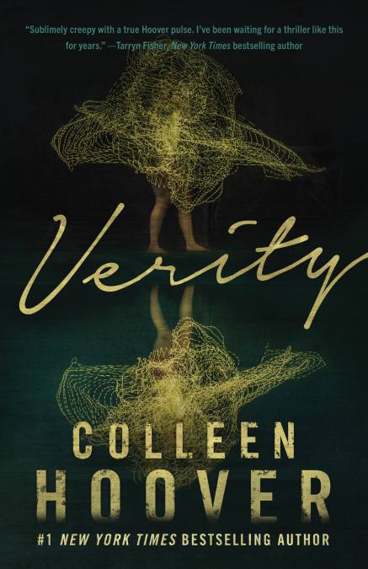 | “Verity” by Colleen Hover | Lowen Ashleigh is a struggling writer on the brink of financial ruin when she accepts the job offer of a lifetime. Jeremy Crawford, husband of bestselling author Verity Crawford, has hired Lowen to complete the remaining books in a successful series his injured wife is unable to finish.  Lowen arrives at the Crawford home, ready to sort through years of Verity's notes and outlines, hoping to find enough material to get her started. What Lowen doesn't expect to uncover in the chaotic office is an unfinished autobiography Verity never intended for anyone to read. Page after page of bone-chilling admissions, including Verity's recollection of what really happened the day her daughter died.  Lowen decides to keep the manuscript hidden from Jeremy, knowing its contents would devastate the already grieving father. But as Lowen's feelings for Jeremy begin to intensify, she recognizes all the ways she could benefit if he were to read his wife's words. After all, no matter how devoted Jeremy is to his injured wife, a truth this horrifying would make it impossible for him to continue to love her.
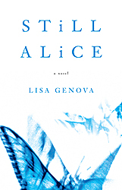 | “Still Alice” by Lisa Genova | Still Alice is a compelling debut novel about a 50-year-old woman's sudden descent into early onset Alzheimer's disease, written by first-time author Lisa Genova, who holds a Ph. D in neuroscience from Harvard University.  Alice Howland, happily married with three grown children and a house on the Cape, is a celebrated Harvard professor at the height of her career when she notices a forgetfulness creeping into her life. As confusion starts to cloud her thinking and her memory begins to fail her, she receives a devastating diagnosis: early onset Alzheimer's disease. Fiercely independent, Alice struggles to maintain her lifestyle and live in the moment, even as her sense of self is being stripped away. In turns heartbreaking, inspiring and terrifying, Still Alice captures in remarkable detail what's it's like to literally lose your mind...
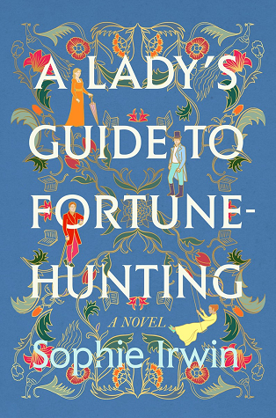 | “A Lady’s Guide to Fortune Hunting” by Sophie Irwin | Kitty Talbot needs a fortune. Or rather, she needs a husband who has a fortune. Left with her father’s massive debts, she has only twelve weeks to save her family from ruin.  Kitty has never been one to back down from a challenge, so she leaves home and heads toward the most dangerous battleground in all of England: the London season.  Kitty may be neither accomplished nor especially genteel—but she is utterly single-minded; imbued with cunning and ingenuity, she knows that risk is just part of the game.  The only thing she doesn’t anticipate is Lord Radcliffe. The worldly Radcliffe sees Kitty for the mercenary fortune-hunter that she really is and is determined to scotch her plans at all costs, until their parrying takes a completely different turn...  This is a frothy pleasure, full of brilliant repartee and enticing wit—one that readers will find an irresistible delight.
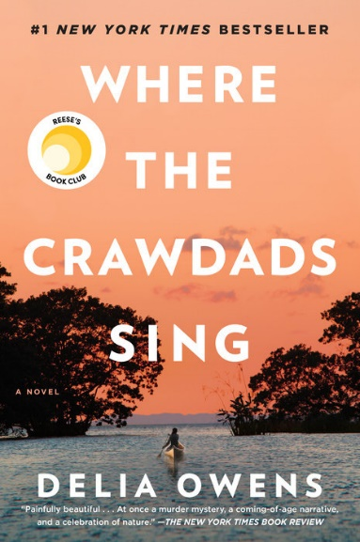 | “Where the Crawdads Sing” by Delta Owens | In Where the Crawdads Sing, Owens juxtaposes an exquisite ode to the natural world against a profound coming of age story and haunting mystery. Thought-provoking, wise, and deeply moving, Owens’s debut novel reminds us that we are forever shaped by the child within us, while also subject to the beautiful and violent secrets that nature keeps.  The story asks how isolation influences the behavior of a young woman, who like all of us, has the genetic propensity to belong to a group. The clues to the mystery are brushed into the lush habitat and natural histories of its wild creatures.
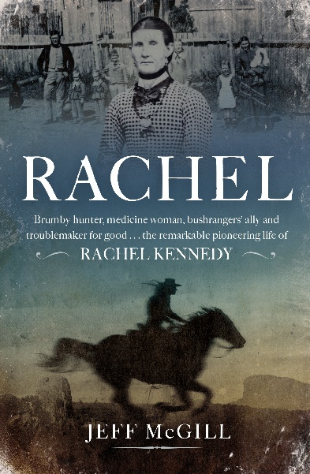 | “Rachel” by Jeff McGill | Rachel Kennedy was a colonial folk hero. Born in the wild and remote Warrumbungle mountains of western New South Wales in 1845, she was described by Duke Tritton of The Bulletin as Australia's greatest pioneer woman of them all. Rachel caught brumbies, hid bushrangers, went to war with squatter kings, fed starving families during the shearing strikes, worked as a revered bush nurse and midwife, and fought for the underdog after observing the bitter experiences of the Chinese on the goldfields. She also built rare friendships with Aboriginal people, including a lifelong relationship with her 'sister' Mary Jane Cain, a proud campaigner for the rights of her people. Meticulously researched and written with compelling energy, this is a vivid and at times heartbreaking story of a pioneering woman who left a legacy that went well beyond her lifetime.

Biography and Non-Fiction

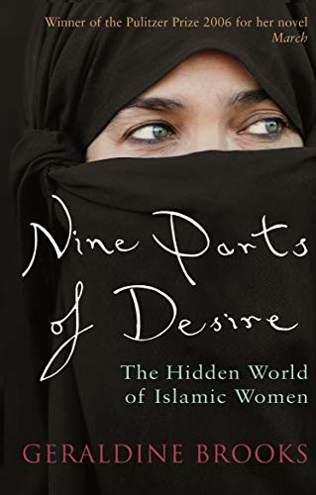 | ‘Nine Parts of Desire: The Hidden World of Islamic Women’ by Geraldine Brooks | As a prizewinning foreign correspondent for The Wall Street Journal, Geraldine Brooks spent six years covering the Middle East through wars, insurrections, and the volcanic upheaval of resurgent fundamentalism. Yet for her, headline events were only the backdrop to a less obvious but more enduring drama: the daily life of Muslim women. ‘Nine Parts of Desire’ is the story of Brooks' intrepid journey toward an understanding of the women behind the veils, and of the often contradictory political, religious, and cultural forces that shape their lives. Defying our stereotypes about the Muslim world, Brooks' acute analysis of the world's fastest growing religion deftly illustrates how Islam's holiest texts have been misused to justify repression of women, and how male pride and power have warped the original message of a once liberating faith.
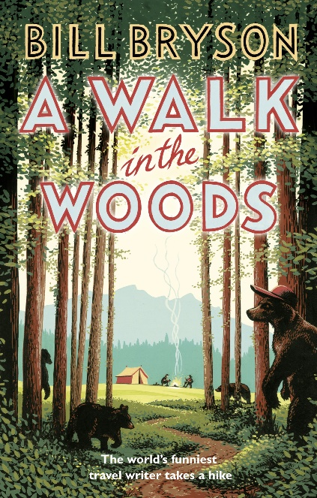 | ‘A Walk in the Woods’ by Bill Bryson | Bryson gets the idea to hike the Appalachian Trail shortly after moving to Hanover, New Hampshire, when he stumbles onto part of the trail on a short hike near his home. He has no real wilderness experience, so he asks around and reads up on the trail, discovering that the perils awaiting him include snakebites, bear attacks, poison ivy, flooding rivers, and a long list of injuries and diseases he might fall victim to. To prepare, Bryson heads to his town's sporting goods store and spends an afternoon with Dave Mengle, who he has been told is a local expert on the Trail. Mengle presents him with a barrage of choices of packs, sleeping bags, cook sets, boots, tents, and thermal clothing. Bryson spends a small fortune and is left wondering what he's gotten himself into.
 | 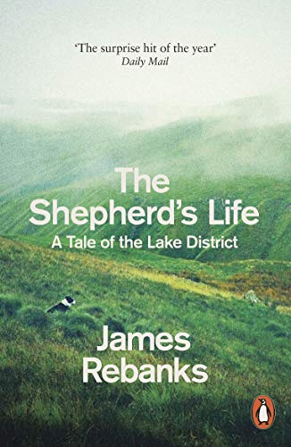  ‘The Shepherd’s Life: A Tale of the Lake District’ by James Rebanks | A story of the Lake District and its people which could redefine the literature of rural life. Some people's lives are entirely their own creations. James Rebanks' isn't. The first son of a shepherd, who was the first son of a shepherd himself, he and his family have lived and worked in and around the Lake District for generations. Their way of life is ordered by the seasons and the work they demand, and has been for hundreds of years. A Viking would understand the work they do: sending the sheep to the fells in the summer and making the hay; the autumn fairs where the flocks are replenished; the gruelling toil of winter when the sheep must be kept alive, and the light-headedness that comes with spring, as the lambs are born and the sheep get ready to return to the fells. These modern dispatches from an ancient landscape tell the story of a deep-rooted attachment to place, describing a way of life that is little noticed and yet has profoundly shaped this landscape. In evocative and lucid prose, James Rebanks takes us through a shepherd's year, offering a unique account of rural life and a fundamental connection with the land that most of us have lost. It is a story of working lives, the people around him, his childhood, his parents and grandparents, a people who exist and endure even as the world changes around them. Many stories are of people working desperately hard to leave a place. This is the story of someone trying desperately hard to stay. James Rebanks is the Herdwick Shepherd. His family has farmed in the same area for more than six hundred years
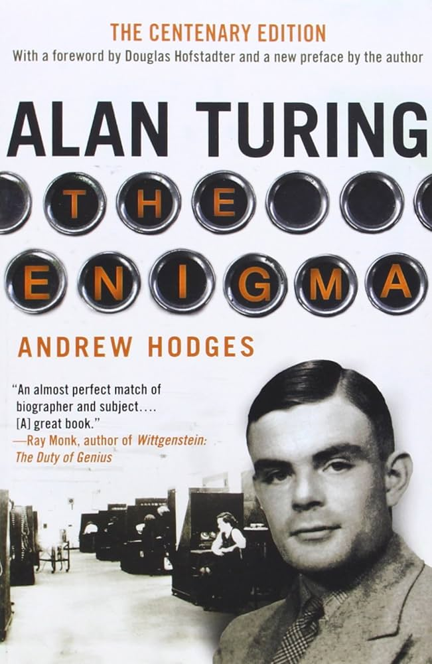 | ‘Alan Turing: The Enigma’ by Andrew Hodges | Alan Turing was the extraordinary Cambridge mathematician who masterminded the cracking of the German Enigma ciphers and transformed the Second World War. But his vision went far beyond this crucial achievement. Before the war he had formulated the concept of the universal machine, and in 1945 he turned this into the first design for a digital computer.  Turing's far-sighted plans for the digital era forged ahead into a vision for Artificial Intelligence. However, in 1952 his homosexuality rendered him a criminal and he was subjected to humiliating treatment. In 1954, aged 41, Alan Turing committed suicide and one of Britain's greatest scientific minds was lost.
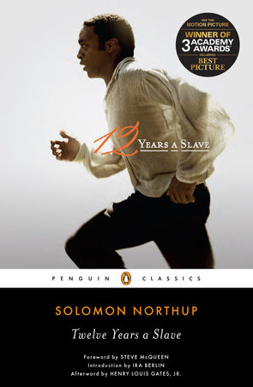 | ‘Twelve Years a Slave’ by Solomon Northup | 'For sheer drama, few accounts of slavery match Solomon Northup's tale of abduction from freedom and forcible enslavement.' Ira Berlin Perhaps the best written of all the slave narratives, ’12 Years a Slave’ is a harrowing memoir about one of the darkest periods in American history. It recounts how Solomon Northup, born a free man in New York, was lured to Washington, D.C., in 1841 with the promise of fast money, then drugged and beaten and sold into slavery. He spent the next twelve years of his life in captivity on a Louisiana cotton plantation. After his rescue, Northup published this exceptionally vivid and detailed account of slave life. It became an immediate bestseller and today is recognized for its unusual insight and eloquence as one of the very few portraits of American slavery produced by someone as educated as Solomon Northup, or by someone with the dual perspective of having been both a free man and a slave

